Priyanka Mishra
Freelancing Content Writing Professional

Contact No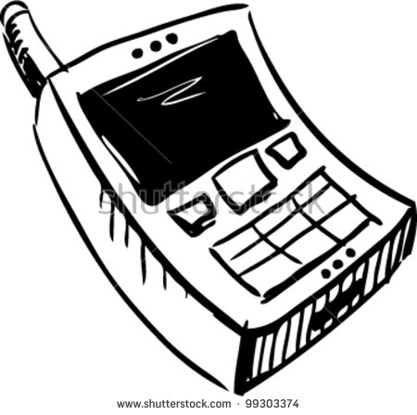 9555987320
Current Location: Ghaziabad E-mail: 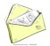misrapriyanka1982@gmail.com

I’m a Content Writing Professional looking for good projects to work on to brush up skills and excel my career in this arena.

My Dossier

Qualification
Degree | Year | Board/University | Percentage
B.com(Regular) | 2004 | Chaudhary Charan Singh University | 62%
S.S.C. (Com) | 2000 | I.S.C. Board | 76%
H.S.C. (Com) | 1998 | I.S.C. Board | 72%

Experience
- Present Company: Freelancing
Role: Content Writer
Duration: June 2016 till date

Responsibilities as a Content Writer
- To understands the requirement of the project.
- To go for client call or meeting to get an idea what they actually want.
- To study client’s products and services
- To do research work and competitor’s websites
- To write genuine and organic content
- To do proof reading and grammar check by using tools like grammarly.
- To do plagiarism test as well on the tools and try to make the content 100% unique.
- To check out keywords density
- To keep a check on sentence formation and length
- To send it for finalization to the client and make changes if required.
- Then final uploading

Project Links
www.menspersonalcare.in-ongoing
www.badrinathinfo.in- ongoing
www.himalayantrekntour.com
www.darzi4u.com
www.brothersrenttoown.com
www.haircafelounge.com
www.mymoneywala.com
Computer Knowledge
- MS Word, MS Office ,Internet(Surfing ,Browsing)
Skills
- Good in Communication, Convincing, Patience, Oratorical Skills, Leadership, content writing.
- Well versed with grammar checking tools and plagiarism tool.

Talents
- Tactful and Punctual
- Adjusting and easily build relationship with people
- Confident ,Committed and Loyal
- Good Team Player

Personal Dossier
- Date of Birth : 18.Oct.1982
- Husband’s name : Mr. Prabhat Mishra
- Mother tongue : Hindi
- Nationality : Indian
- Languages : Hindi & English
- Permanent address : Satpura,Kaushambi,Ghaziabad,UP

Thanks for visiting my profile!
Signature: Priyanka Mishra

